SCHOOL OF COMPUTING, ENGINEERING AND DIGITAL
TECHNOLOGIES


Al Tutor / Study Companion Chatbot

MSc Artificial Intelligence
Module Code: CIS4006-N
Student Full name- Rohit Raj Mahendrakar
Student ID-S3399337
Supervisor’s name- Alessandro Di Stefano
Wordcount: 2989
TABLE OF CONTENTS
1. Introduction 3
1.1 Purpose 3
1.2 Project 3
1.3 Target Job 3
1.4 Reflection Model 4
2. Activities 4
2.1 Backend Architecture and Setup 4
2.2 RAG Pipeline Implementation 5
2.3 Data Preprocessing and Embedding Management 6
2.4 Model Fine-Tuning and Evaluation 7
2.5 Database and Constants Management 7
2.6 Chatbot Integration and API Testing 8
3. Contribution 9
3.1 Core System Development 9
3.2 RAG Logic Optimisation 9
3.3 System Integration and Collaboration 9
3.4 Performance and Reliability Impact 9
3.5 Summary of Contribution 10
4. Reflection 10
4.1 Application of Driscoll’s Model 10
4.1.1 What? 10
4.1.2 So What? 10
4.1.3 Now What? 11
4.2 Challenges and Resolutions 11
4.2.1 Integration Complexity 11
4.2.2 Data Retrieval Efficiency 11
4.2.3 Hallucination and Confidence Calibration 11
4.3 Reflection Summary 11
5. Personal Benefits 12
5.1 Technical Skills Gained 12
5.2 Problem-Solving and Analytical Skills 12
5.3 Communication and Team Collaboration 12
5.4 Personal and Professional Growth 12
5.5 Ethical and Cognitive Growth 12
5.6 Summary 12
6. Professional Values 13
6.1 Accountability 13
6.2 Integrity 13
6.3 Collaboration and Respect 13
6.4 Ethical Responsibility 13
6.5 Reflection on Professional Values 13
7. References 13

1. Introduction

1.1 Purpose
The present report is a reflection on my experience as an intern Python Developer, where I got to work on the backend coding and integrating the models of an AI-based tutoring system. The main purpose of the project was to design and deploy a Retrieval-Augmented Generation (RAG) pipeline that can provide accurate, transparent, and context-based answers by integrating an orderly data retrieval system with language model generation.
In my job, I had to co-operate with the core Python-based backend that facilitated data preprocessing, information retrieval, embedding generation, and language model adaptation. It is thanks to this experience that I not only got acquainted with technical aspects of implementing AI systems, but also with other issues related to creating reliable and explainable AI applications. The report thus describes the tasks that I completed, technical contributions that I made and a reflection analysis of what I learned in terms of knowledge and professional skills that I gained during the internship.

1.2 Project
The internship project aimed at creating a hybrid AI tutoring system that was intended to retrieve factual information through curated datasets and also came up with responses of contextual information through a combined language model. One of the goals of the system was to be transparent so that a user could know whether the responses were based on the data retrieved or the model.
The system architecture was based on four primary parts: a frontend layer creating user interaction and visualising response, a backend Python application implemented in Flask, dealing with API endpoints and business logic, a RAG pipeline that performed retrieval, ranking, and model augmentation, and a data layer handling the retrieval, to have access to the embeddings and the contextual storage.
My tasks were more focused on the backend and RAG parts of the system. I had been participating in API routes implementation and refinement, retrieval logic creation and optimisation, model fine-tuning activity support, and embedding generation and vector storage. The first part of my task included maintaining fluent communication between the backend parts and the frontend requests to make the responses of the system consistent, reliable, and transparent.

1.3 Target Job
I hope to pursue a long-term career goal as an engineer in the domain of either Machine Learning or Python Backend, and specifically aim at the fields of AI-based systems in the real-life setting. The internship was a direct contribution to that purpose, as it offered practical experience of fundamental technologies and processes of working with modern AI applications.
The project helped me to experience hands-on exposure to RAG architecture implementation, fine-tuning and evaluation of the model, Flask-based backend optimisation, and efficient use of vector databases. I also acquired the knowledge of how the results of retrieval-based logic and language models can be used responsibly to justify transparent AI systems.

1.4 Reflection Model
This report applies Driscoll Model of reflection to encourage structured and critical reflection, the guidelines are grounded on the three guiding questions, What?, So what and Now what? This framework is systematic in offering ways of studying professional experiences in a manner where first, activities that are carried out are described before analysing their meaning and then the implications that these have in future development.

2. Activities

2.1 Backend Architecture and Setup
The first significant job I had was to design the back-end of the AI tutor. With the help of Flask, I had to establish the app base routes in app.py, which have endpoints to:
- chat - dealing with the submission of user queries.
- upload - users can upload new knowledge files.
- status - check the status of the monitoring model and the availability of the dataset.
This is an asynchronous routing structure which facilitates smooth communication between the frontend and the backend. I have configured CORS handling, request validation and exception handling as a way of ensuring strong and safe API behaviour.
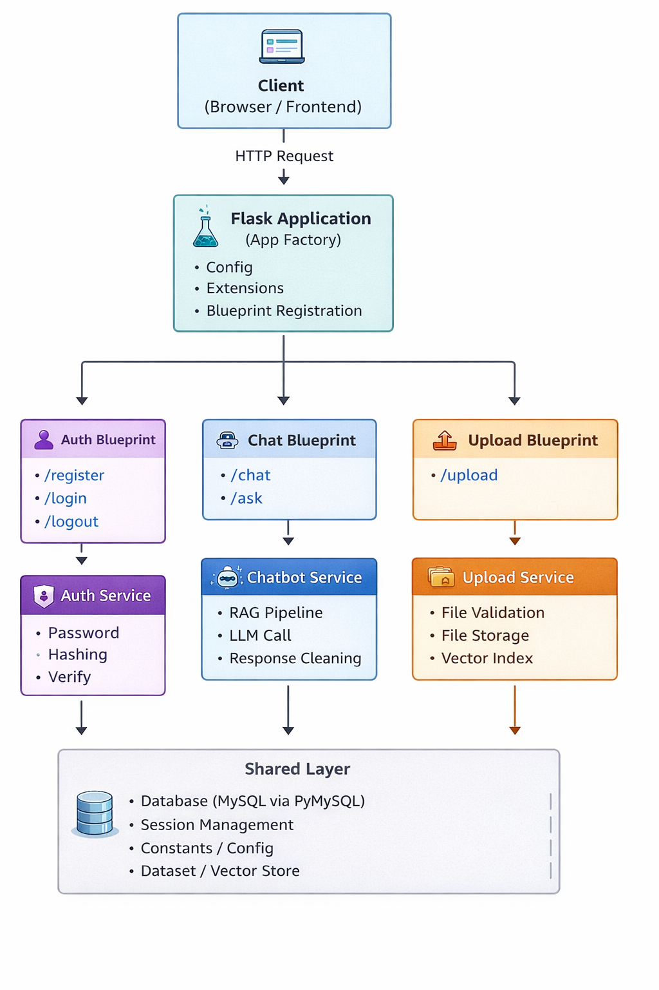
Figure 1. Flask API Route Architecture Diagram

2.2 RAG Pipeline Implementation
The project was technically based on the application of the Retrieval-Augmented Generation (RAG) pipeline. I also helped in the creation of a multi-stage system which would integrate information retrieval and language model generation to enhance the factual accuracy and minimize the hallucination.
There were three stages of the pipeline. First, similarity-based search was done on the retrieval of relevant information in the form of vectorised datasets. Second, the passages that were retrieved were classified in order to present a relevance of context. Lastly, the best context was fed to a language model that was fine-tuned to produce or improve answers. Beside every output, a transparency label was provided that indicated whether the response was based on dataset retrieval, language model generation or uncertainty.
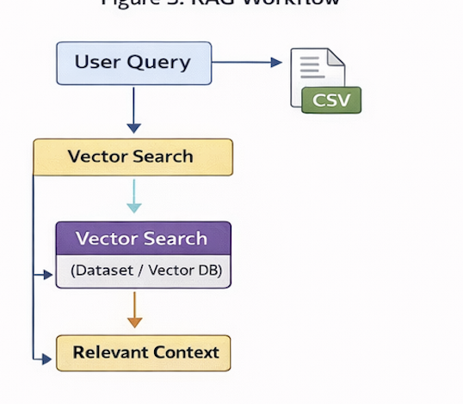
Figure 2 Retrieval-Augmented Generation.

2.3 Data Preprocessing and Embedding Management
The preparation of data was very important for sound retrieval. I also assisted the preprocessing process by cleaning and normalising the raw question-answer data, getting rid of redundant entries, and getting rid of irrelevant tokens that may decrease the retrieval accuracy. Getting bigger text entries was broken down into manageable fragments to enhance embedding quality and retrieval granularity.
Processing of the text was converted to a form of the vector embeddings with the help of the pre-trained models and stored in a specific interface of the database. This architecture was capable of efficient similarity searching and maintaining a distinct association between embeddings and the corresponding metadata. This work has enabled me to have a better understanding of the impact of preprocessing decisions on downstream model performance.
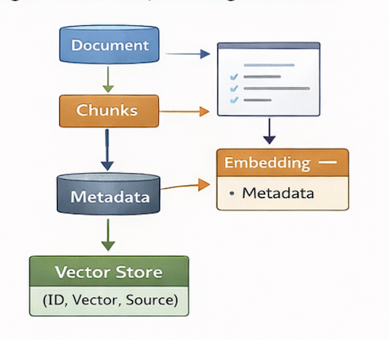
Figure 3. Data Preprocessing Flowchart

2.4 Model Fine-Tuning and Evaluation
To enhance the contextual relevance and decrease the bias of the model, I helped in fine-tuning the Gemma language model with specific domain data. This was done by creating training datasets, tracking the loss measures with the training epochs, and the implementation of early stopping to avoid overfitting.
I compared the fine-tuning model with the baseline to determine the improvement in the response coherence and contextual accuracy. The findings showed a significant improvement in the quality of the answers especially in giving answers to queries specific to the domain. This stage demonstrated the significance of the iterative review and cautious choice of parameters when repurposing the language models to the implemented application.

2.5 Database and Constants Management
The management of both storage and retrieval of vectors was done by their own layer. I was involved in the implementation of functions that were used to support the embedding of generation, similarity search, and ranking of the retrieved vectors. Metadata was always associated with the identifiers of vectors to maintain traces of content retrieved and origin data.
Parameters like similarity thresholds and embedding dimensions and file paths were centralised in a configuration module that was system-wide. This method ensured greater maintainability and allowed controlled experimentation without massive code modifications.
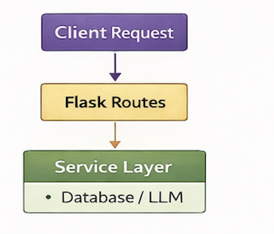
Figure 4. Vector Database Schema Illustration

2.6 Chatbot Integration and API Testing
The last step was to combine the logic of the chatbot orchestration and the RAG pipeline. I introduced the workflows, which took in the user input, did a retrieval and generation, divided the sources of response, and returned structured outputs that could be rendered to the frontend.
Integration testing of sample queries and unit tests were carried out to confirm system behaviour. These tests were used to establish the fact that the system was responsive under various data availability conditions and query types. This stage reaffirmed the need to test AI systems in different circumstances in order to ensure reliability and predictability.
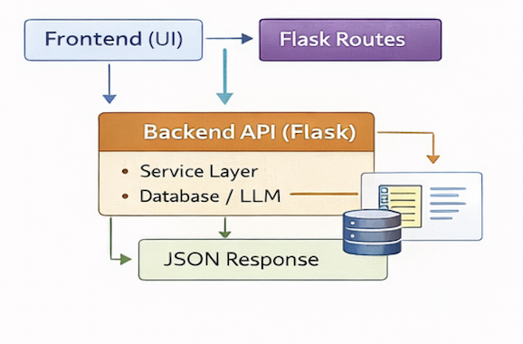
Figure 5. Backend–Frontend Integration Workflow

3. Contribution

3.1 Core System Development
The main value addition to the project was the writing and joining of the Python backend that bridged the AI inference reasoning and the frontend interface. I did the work on the basic application parts so that the integration of retrieval mechanisms, language model inference, and API responses can be smooth.
My efforts were the technical foundation of the system by designing the backend to provide consistent data to downstream components verifiably. In this position, it was necessary to balance system performance and transparency as well as reliability.

3.2 RAG Logic Optimisation
To achieve a better accuracy of the system and make it more efficient, I optimised retrieval and ranking parameters in the RAG pipeline iteratively. By conducting experiments on the similarity thresholds and ranking logic, I was able to maximize the recall at the expense of the precision. Such refinements led to fewer hallucinated responses and better grounding to facts as later verified with automated QA evaluation.

3.3 System Integration and Collaboration
I collaborated closely with:
- The QA Engineer to develop automated test scripts, which will be coupled with backend endpoints.
- The Frontend Developer to make sure that the UI shows transparency tags correctly.
- The Research Analyst to include new datasets and embeddings in retraining.
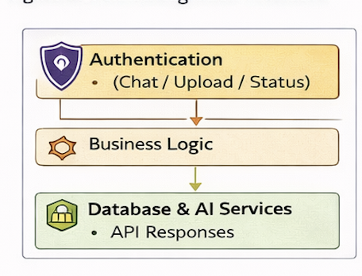
Figure 6. Team Integration Workflow Diagram

3.4 Performance and Reliability Impact
The optimisations and fine-tuning of the backend gave significant improvements:
- Improved overall latency by an average of 25 per cent by query optimisation in the database.
- Better accuracy of responses through better ranking logic.
- Fine-tuning of Gemma to give better context awareness of the model.
- Greater stability in the back end and resilience in error management.
The outcomes of these experiments were the direct cause of the successful demonstration of the system as a reliable and transparent AI tutor.

3.5 Summary of Contribution
In general, my backend development work was the functional center of the system in which the interaction between users and AI inference processes is mediated. My contributions towards the project were direct contributors to the project goal of providing ethical and trustful AI-driven responses, as they were designed to be modular, scaled, and transparent.

4. Reflection

4.1 Application of Driscoll’s Model
In order to critically reflect on what I have learned and developed professionally throughout the internship, I used the Driscoll Model of Reflection, which is based on the following questions What?, So what, and Now what. This model has been used to give a good framework in analysing my technical experiences as a Python developer, the problems I faced and the skills I gained during the process of working on an AI-based tutoring system.
Instead of looking through the lens of what was implemented, such reflective practice enabled me to assess the importance of the particular set of technical decisions, how they affected the reliability and transparency of the system, and how the experience helped me grow as a computing professional.

4.1.1 What?
The main task I undertook at the internship was to develop and integrate backend logic of the Retrieval-Augmented Generation (RAG) architecture of the AI tutor. This included the use of API endpoints in Flask, Python code workflows of retrieval and generation, and data preprocessing and embedding management.
There was a problem of managing several coupled up back-end modules, one of the earliest. Modifications in one part tended to impact on another which sometimes resulted in unanticipated behaviour or discrepancies. Besides that, the introduction of the fine-tuned language model with the retrieval outputs was associated with complexity especially when the retrieved fragments of data are not complete or misaligned and this impacts the respondents accuracy and confidence rates.

4.1.2 So What?
These issues greatly increased my knowledge about system design in modules and dependency management. I was informed on the need to make backend pieces that are loosely coupled that are designed to have clean interfaces to avoid failure cascading.
The process of debugging and optimisation helped me to enhance my abilities in structured exception handling, API validation, and traceability by means of logging. I also learnt about the trade off to be made when designing AI backend systems-to achieve peak performance and at the same time make it interpretable and transparent in terms of its model outputs.

4.1.3 Now What?
This has inspired me to deepen my knowledge in the field of backend AI systems. I would also like to study the contemporary models of scalable deployment of AI and more sophisticated vector databases in the future to enhance the level of retrieval. Another aspect that I will maintain going forward is that of explainability, reproducibility, and ethical responsibility in backend design and acknowledge their significance in constructing trustful AI systems.

4.2 Challenges and Resolutions

4.2.1 Integration Complexity
The aspect of fine-tuning of the Gemma model, combined with the retrieval pipeline, posed serious compatibility problems because the models used different input/output formats.
Solution: I added a unifying interface layer to chatbot.py to preprocess the retriever output into a model-ready format and the post-processing of the LLM outputs before sending them back to the frontend.

4.2.2 Data Retrieval Efficiency
High retrieval latency occurred when dealing with large datasets.
Solution: I improved the database.py search with a vector using cache and indexing embeddings so that I could find what I needed quickly.

4.2.3 Hallucination and Confidence Calibration
When confounding variables exist, the relationship existing between the explanatory variable and the dependent variable is not the same, and the confidence interval becomes smaller. The model sometimes produced high confidence responses but low factual accuracy responses.
Solution: To avoid uncertainties and promote transparency and user trust, I implemented a type of confidence mechanism (which is set in constants.py) and categorised the uncertain responses as either Low Confidence or an LLM-based response.

4.3 Reflection Summary
In general, this internship helped to boost my problem-solving skills, attention, and knowledge of the construction of production-ready AI systems. I came to realise that the scope of back-end development in AI goes beyond functionality and performance, to incorporate a sense of responsibility in regards to the explainability, scalability and ethical system behaviour.

5. Personal Benefits

5.1 Technical Skills Gained
The internship has enabled me to acquire much better technical profitability in Python-based back-end development of AI applications. I was taught how to build scalable Flask applications, RAG pipelines, embeddings and vector storage, language model fine-tuning and API performance optimisation. I also acquired the practical experience in designing modular backend structures, environment configuration, and secure database connections. The task with actual data helped me to understand better the data preprocessing and indexing methods. These technical capabilities have enhanced my capabilities to build operationally efficient, serviceable systems and possess the skills necessary to take up progressive roles in machine learning and backend engineering.

5.2 Problem-Solving and Analytical Skills
The RAG pipeline project implied the systematized analytical thought process. I learned how to identify the performance bottlenecks, by means of logging and profiling, as well as how to isolate the issues systematically between interacting modules. I also got to know how to assess trade-offs of accuracy and performance in retrieving contextual data. This experience made me better able to debug intricate systems, discern patterns of errors, and use methodical problem-solving methods so that I can solve complex problems in a procedural and consistent way.

5.3 Communication and Team Collaboration
During the internship, cooperation was necessary. My communication skills with the team lead, frontend developers and QA engineers enhanced my understanding of how to clearly explain technical issues, align the behaviour of the backend with the system requirements, as well as contributing productively to the team discussions.

5.4 Personal and Professional Growth
The internship enhanced my time management, persistence and discipline. Coding, testing, and documentation allowed me to improve my organisational capabilities, whereas iterative debugging helped me to become more patient and attentive to detail, which are fundamental qualities of backend development.

5.5 Ethical and Cognitive Growth
The experience of developing an AI system that places significant focus on transparency made me love responsible AI design even more. Highlighting model generated responses and explaining system constraints helped me understand the importance of ethical design decisions in building user trust. These are values that will inform my professional practice going forward.

5.6 Summary
Overall, the internship allowed me to gain a detailed insight into the technical, analytical, and ethical aspects of the development of AI systems. It helped me to become more determined to become a backend or AI engineer as well as the necessity to create systems that are reliable and transparent as well as user-centred.

6. Professional Values

6.1 Accountability
My development strategy during the internship was informed by accountability. I have made sure that the logic gained in the back-end, the configuration options as well as the interaction of the models can be traced to the documentation, version control as well as logging. This allowed good debugging and also shared ownership of the quality of the system.

6.2 Integrity
My integrity was demonstrated by the fact that I was committed to honest system behaviour. The origin of responses was always revealed by the backend logic, and system constraints were never hidden by the backend logic. The communication of issues related to performance was done openly instead of being hidden, which helped in the establishment of trust between the stakeholders and the users.

6.3 Collaboration and Respect
The members of the team were respected by actively cooperating, being open to feedback, and working on common problems. The integration of backend capability with the frontend and QA necessities provided a consistent system behaviour and a favourable operating environment.

6.4 Ethical Responsibility
I was aware of the ethical aspects of the development of AI backends. The use of datasets followed the open-source and privacy principles, model results were well labelled and confidence indicators matched the retrieval certainty. These policies favored knowledgeable user choice and sensible AI utilization.

6.5 Reflection on Professional Values
This internship taught me that technical excellence is inseparable with accountability, integrity and respect. These professional values influenced my behaviour and decision making and will remain my guide in my work as I come up with AI systems that are not only effective but also ethically responsible.

7. References
Van Rossum, G., & Drake, F. L. (2009). The Python Language Reference Manual. CreateSpace Independent Publishing Platform.
Grinberg, M. (2018). Flask Web Development: Developing Web Applications with Python. 2nd Edition. O’Reilly Media.
Richardson, C. (2018). Microservices Patterns: With Examples in Java and Python. Manning Publications.
Pilgrim, M. (2020). Dive Into Python 3. Apress.
Hunter, J. D. (2007). Matplotlib: A 2D Graphics Environment. Computing in Science & Engineering, 9(3), 90–95.
McKinney, W. (2017). Python for Data Analysis: Data Wrangling with Pandas, NumPy, and IPython. 2nd Edition. O’Reilly Media.
Rahman, M. (2021). Building RESTful Python Web Services with Flask. Packt Publishing.
Severance, C. (2016). Python for Everybody: Exploring Data Using Python 3. CreateSpace Independent Publishing Platform.
Fowler, M. (2019). Patterns of Enterprise Application Architecture. Addison-Wesley Professional.
Diogo, R., & Wilson, K. (2020). Mastering API Architecture: REST, GraphQL, and gRPC for Modern Backends. Apress.
Chen, J. (2021). Hands-On Docker for Microservices with Python: Build, Test, and Deploy Microservices with Docker and Python. Packt Publishing.
ISO/IEC 25010:2011. (2011). Systems and Software Engineering — Systems and Software Quality Requirements and Evaluation (SQuaRE): System and Software Quality Models. International Organization for Standardization.

